Questionnaire for fieldwork

Link naar de vragenlijst: https://app.maptionnaire.com/q/3pyu2c8laa27



Publicatie id: 888yyj2lny68

Publicatiedatum: 29-4-2024

Print datum: 14-6-2024

Page 1

# Welcome!

Dear participants, Welcome to our research! In this questionnaire we would like to focus on your experience with a Warning System. Before and after your bicycle rides, we would like to ask you some questions. You can find all information about research approach, consent, privacy, and contact details in the information brief. Best wishes, The Research Team, Annemarie, Deepak, Georgios, Mario

Page 2

# Personal information

What is your participant number?

Waarde mag niet lager zijn dan 1

Waarde mag niet hoger zijn dan 150

What is your nationality?

What is your gender?

☐ Male

☐ Female

☐ Non-binary/other

What is your age in years?

☐ <25

☐ 25-35

☐ 36-45

☐ 46-55

☐ 56-65

☐ 66-75

☐ 75<

What is weight in kilograms?

☐ <60

☐ 61-70

☐ 71-80

☐ 81-90

☐ 91-100

☐ 101-110

☐ 111-120

☐ 121<

What is your length in centimeter?

☐ <150

☐ 150-160

☐ 161-170

☐ 171-180

☐ 181-190

☐ 191-200

☐ 201-210

☐ 210<

How many cups/glasses of caffineated drinks did you drink today, if any?

Are you on medication that affects heart performance?

☐ Yes

☐ No

☐ I don't know

What is your personal net monthly income in Euro?

☐ 0-1000

☐ 1001-1500

☐ 1501-2500

☐ 2501-3000

☐ 3001-3500

☐ 3501-4000

☐ 4001-4500

☐ 4501-5000

☐ >5000

Indicate the highest level of education that you completed.

☐ Primary school

☐ Middle/high school

☐ Vocational education

☐ Academic education

☐ Different

Page 3

# Cycling experience

For how many years have you been cycling at least once per year in The Netherlands?

☐ 0-1

☐ 1-2

☐ 2-5

☐ 5-10

☐ 10+

In how many collisions have you been involved (with other vehicles, bicycles, etc.) in the past 3 years while riding a bicycle?

☐ 0

☐ 1

☐ 2-3

☐ 3-5

☐ 5 or more

☐ I am not sure

How many times did you fall down (in a single crash, e.g., due to potholes, grooves, tram tracks) in the past 3 years?

☐ 0

☐ 1

☐ 2-3

☐ 3-5

☐ 5 or more

☐ I am not sure

How often do you use the following type of bicycle as means of transport?

|  |  |  |  |  |  |  |
| --- | --- | --- | --- | --- | --- | --- |
|  | Never or less than 1 day per year | 1 to 5 days per year | 6 to 11 days per year | 1 to 3 days per month | 1 to 3 days per week | 4 days or more per week |
| Bicycle | ◯ | ◯ | ◯ | ◯ | ◯ | ◯ |
| E-bike | ◯ | ◯ | ◯ | ◯ | ◯ | ◯ |
| Speed pedelec | ◯ | ◯ | ◯ | ◯ | ◯ | ◯ |

Please indicate to what extent you agree or disagree with the following statements, ranging from strongly disagree to strongly agree.

|  |  |  |  |  |  |
| --- | --- | --- | --- | --- | --- |
|  | Strongly disagree | Disagree | Neutral | Agree | Strongly agree |
| I feel safe when I cycle in my city. | ◯ | ◯ | ◯ | ◯ | ◯ |
| I get nervous easily when I cycle. | ◯ | ◯ | ◯ | ◯ | ◯ |
| I often feel that I'm going at a higher speed than I should be going at. | ◯ | ◯ | ◯ | ◯ | ◯ |

# Digital Skills

Do you have a smartphone?

☐ Yes

☐ Yes, but I use it only for calls/messaging

☐ No

Please indicate to what extent you agree or disagree with the following statements, ranging from strongly disagree to strongly agree.

|  |  |  |  |  |  |
| --- | --- | --- | --- | --- | --- |
|  | Never | Rarely | Sometimes | Often | Very often |
| How often have you used a smartphone in the past year to connect to the internet? | ◯ | ◯ | ◯ | ◯ | ◯ |
| How often have you used a navigation app, on your smartphone, in the past year, to plan a trip by car or bicycle? | ◯ | ◯ | ◯ | ◯ | ◯ |
| How often have you used a payment app, on your smartphone, in the past year, to pay, for example in a shop or restaurant? | ◯ | ◯ | ◯ | ◯ | ◯ |
| I am interested in new technologies. | ◯ | ◯ | ◯ | ◯ | ◯ |
| I think that technological developments will have a positive impact on society. | ◯ | ◯ | ◯ | ◯ | ◯ |

Page 4

# Emotions & Flow

We are investigating how people feel when they ride bikes, and how our Warning System affects their riding experience. We are using concepts from psychology to help us. The first concept is that emotions can be described by how energized and positive you feel.

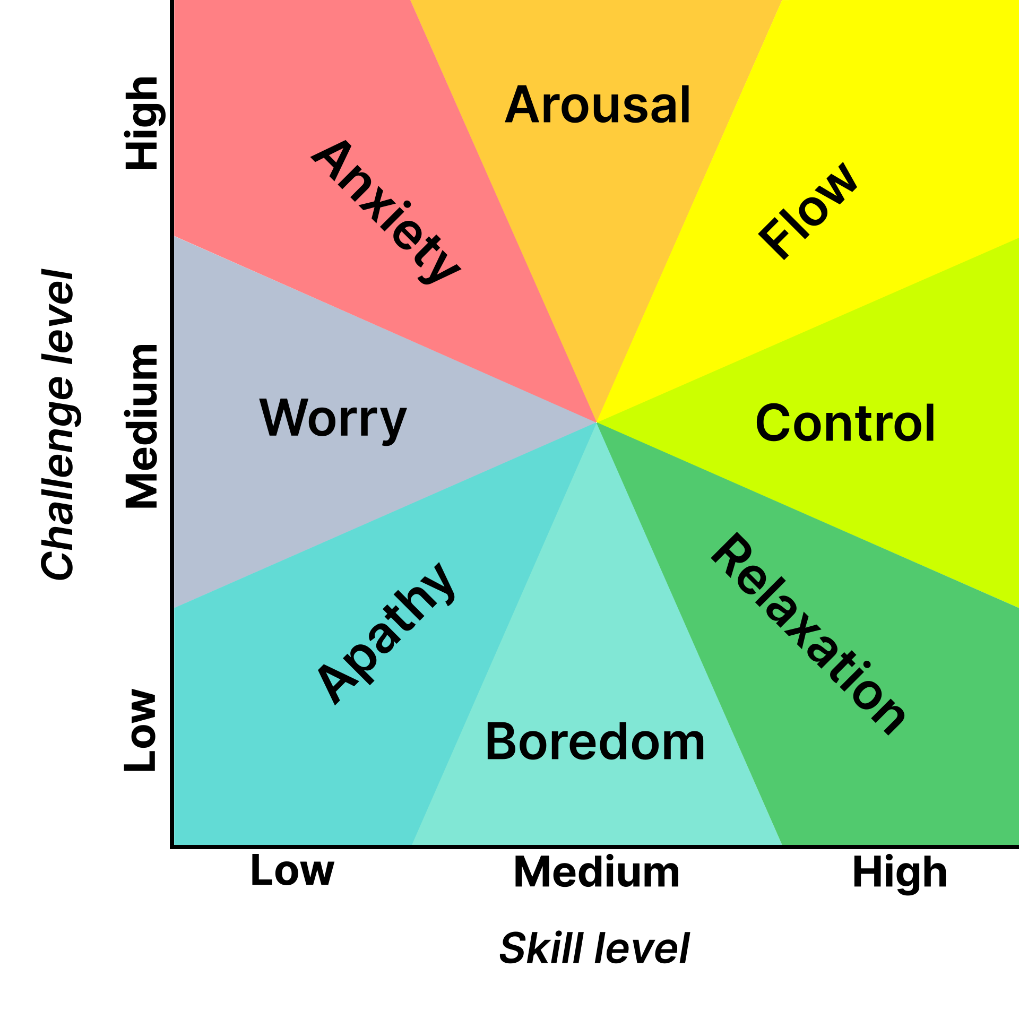

The second concept is about "psychological flow," which is when you feel really engaged in, focused on, and capable for, an activity. We want to know if people feel this way when they ride bikes, what makes them feel that way, and how our system influences those feelings. Since everyone is different, we would like to ask you the following questions.

Please answer the following questions.

|  |  |  |  |  |  |  |
| --- | --- | --- | --- | --- | --- | --- |
|  | Never | Rarely | Sometimes | Often | Very often | Other/I do not know |
| How often do you evaluate your emotions in terms of how energized (cq. activated or aroused) you feel (Fig. 1)? | ◯ | ◯ | ◯ | ◯ | ◯ | ◯ |
| How often do you evaluate your emotions in terms of how pleasant (cq. positive/negative) you feel (Fig. 1)? | ◯ | ◯ | ◯ | ◯ | ◯ | ◯ |
| How easily do you get into a state of psychological flow while cycling (Fig. 2)? | ◯ | ◯ | ◯ | ◯ | ◯ | ◯ |

# Emotions right now

Rate at the slider below this image how energized you feel at the moment.



Voer een waarde in tussen 0 (Low energy) en 100 (High energy)

Please enter the time in HH:MM (e.g., 14:21) at which you gave this rating.

Rate at the slider below this image how pleasant you feel at the moment.



Voer een waarde in tussen 0 (Unpleasant) en 100 (Pleasant)

Please enter the time in HH:MM (e.g., 14:21) at which you answered this question.

# Go for ride 1!

Page 5

# Questions after ride 1

Now that your ride is completed, we would like to ask you about your current feelings, and about your feelings during the ride.

# Emotions right now

Rate at the slider below this image how energized you feel at the moment.



Voer een waarde in tussen 0 (Low Energy) en 100 (High Energy)

Please enter the time in HH:MM (e.g., 14:21) at which you answered this question.

Rate at the slider below this image how pleasant you feel at the moment.



Voer een waarde in tussen 0 (Unpleasant) en 100 (Pleasant)

Please enter the time in HH:MM (e.g., 14:21) at which you answered this question.

Rate to what extent you were in a flow during the ride.

Voer een waarde in tussen 0 (No flow) en 100 (Full flow)

Rate to what extent you felt safe during the ride.

Voer een waarde in tussen 0 (Unsafe) en 100 (Safe)

Please indicate to what extent you agree or disagree with the following statements, ranging from strongly disagree to strongly agree.

|  |  |  |  |  |  |
| --- | --- | --- | --- | --- | --- |
|  | Strongly disagree | Disagree | Neutral | Agree | Strongly agree |
| The bicycle I just used is trustworthy. | ◯ | ◯ | ◯ | ◯ | ◯ |

# Influence of context on your experience

Please rate how the following factors influenced your cycling experience during the route.

|  |  |  |  |  |  |
| --- | --- | --- | --- | --- | --- |
|  | Strongly negative | Negative | Neutral | Positive | Strongly positive |
| The activity of cycling (intensity, length, fatigue, etc.) | ◯ | ◯ | ◯ | ◯ | ◯ |
| Environment (noise, buildings, landscape, etc.) | ◯ | ◯ | ◯ | ◯ | ◯ |
| Road infrastructure (cycling lanes, intersections, pavement quality, etc.) | ◯ | ◯ | ◯ | ◯ | ◯ |
| Other road users (cars, pedestrians, volume, speeds, proximity, etc.) | ◯ | ◯ | ◯ | ◯ | ◯ |
| Weather (wind, temperature, sunshine, etc.) | ◯ | ◯ | ◯ | ◯ | ◯ |
| Mood (average weekly feelings, memories, etc.) | ◯ | ◯ | ◯ | ◯ | ◯ |
| Fitness (personal strength, health condition, etc.) | ◯ | ◯ | ◯ | ◯ | ◯ |

If there were any other influences, please describe them.

Page 6

# Location ratings

Please rate to what extent you think each of the following pictures/locations is safe, ranging from 1 = "unsafe" to 5 = "safe."

|  |  |  |  |  |  |
| --- | --- | --- | --- | --- | --- |
|  | 1 | 2 | 3 | 4 | 5 |
| Please rate to what extent you think the location pictured above is safe. | ◯ | ◯ | ◯ | ◯ | ◯ |

|  |  |  |  |  |  |
| --- | --- | --- | --- | --- | --- |
|  | 1 | 2 | 3 | 4 | 5 |
| Please rate to what extent you think the location pictured above is safe. | ◯ | ◯ | ◯ | ◯ | ◯ |

|  |  |  |  |  |  |
| --- | --- | --- | --- | --- | --- |
|  | 1 | 2 | 3 | 4 | 5 |
| Please rate to what extent you think the location pictured above is safe. | ◯ | ◯ | ◯ | ◯ | ◯ |

|  |  |  |  |  |  |
| --- | --- | --- | --- | --- | --- |
|  | 1 | 2 | 3 | 4 | 5 |
| Please rate to what extent you think the location pictured above is safe. | ◯ | ◯ | ◯ | ◯ | ◯ |

|  |  |  |  |  |  |
| --- | --- | --- | --- | --- | --- |
|  | 1 | 2 | 3 | 4 | 5 |
| Please rate to what extent you think the location pictured above is safe. | ◯ | ◯ | ◯ | ◯ | ◯ |

|  |  |  |  |  |  |
| --- | --- | --- | --- | --- | --- |
|  | 1 | 2 | 3 | 4 | 5 |
| Please rate to what extent you think the location pictured above is safe. | ◯ | ◯ | ◯ | ◯ | ◯ |

|  |  |  |  |  |  |
| --- | --- | --- | --- | --- | --- |
|  | 1 | 2 | 3 | 4 | 5 |
| Please rate to what extent you think the location pictured above is safe. | ◯ | ◯ | ◯ | ◯ | ◯ |

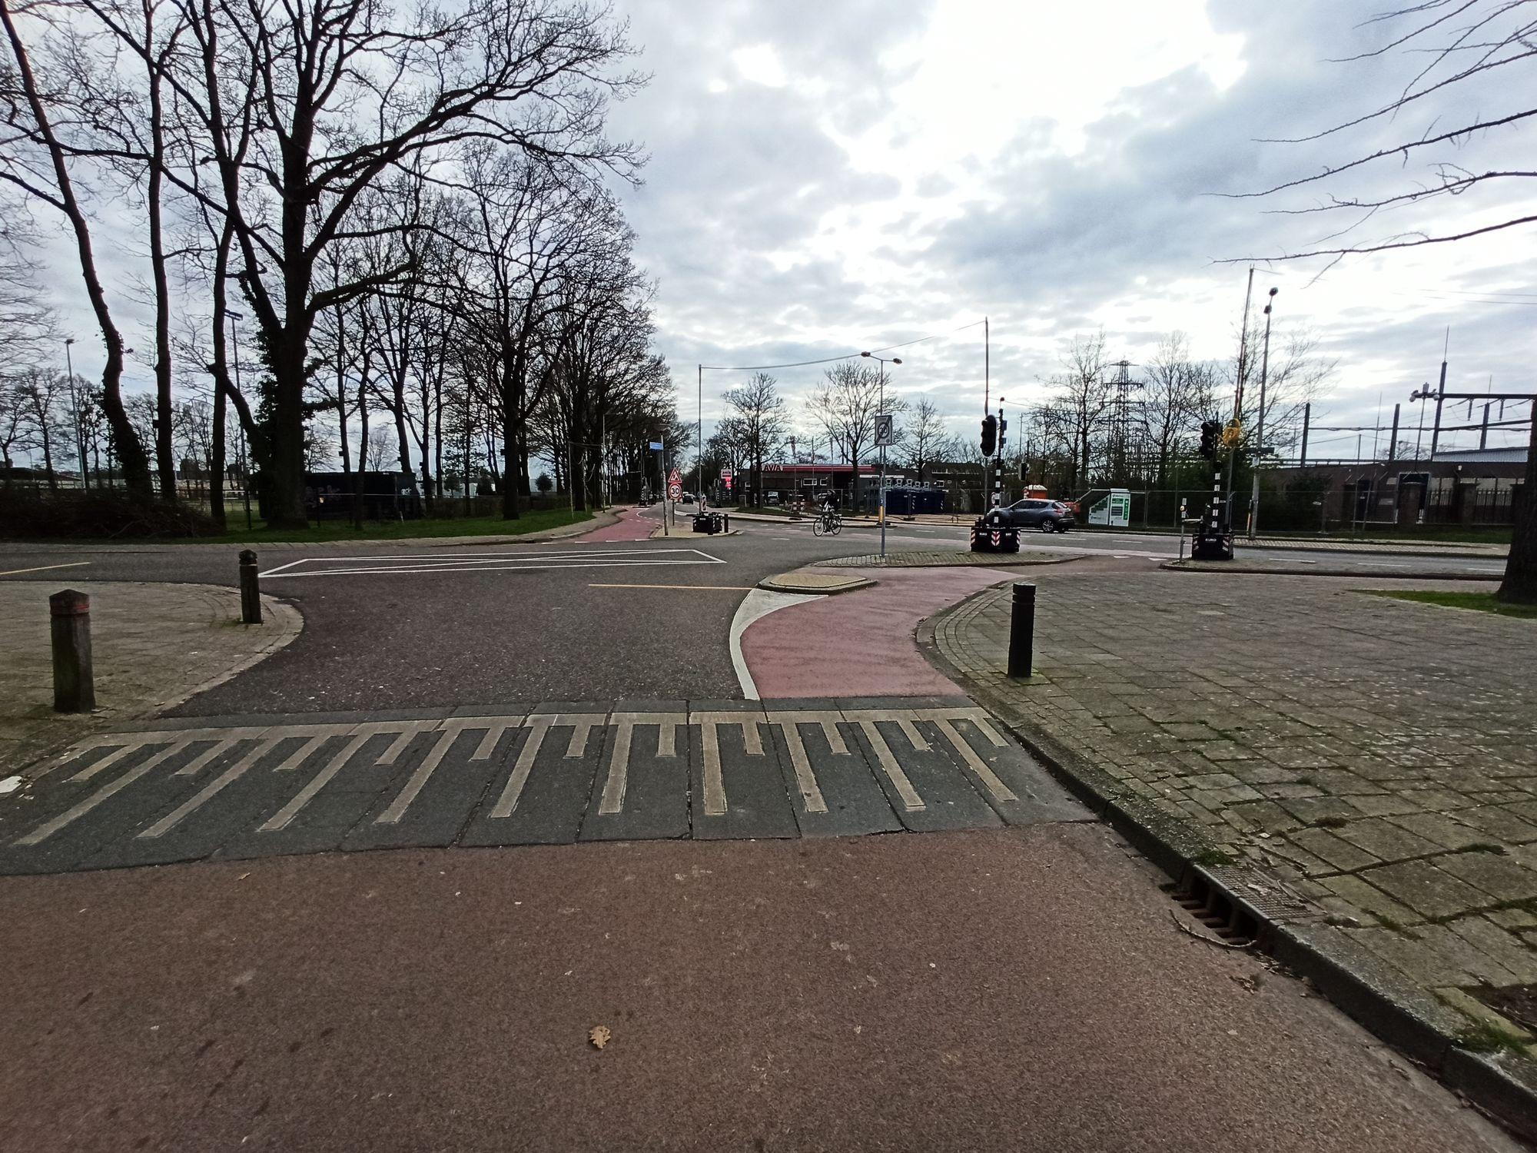

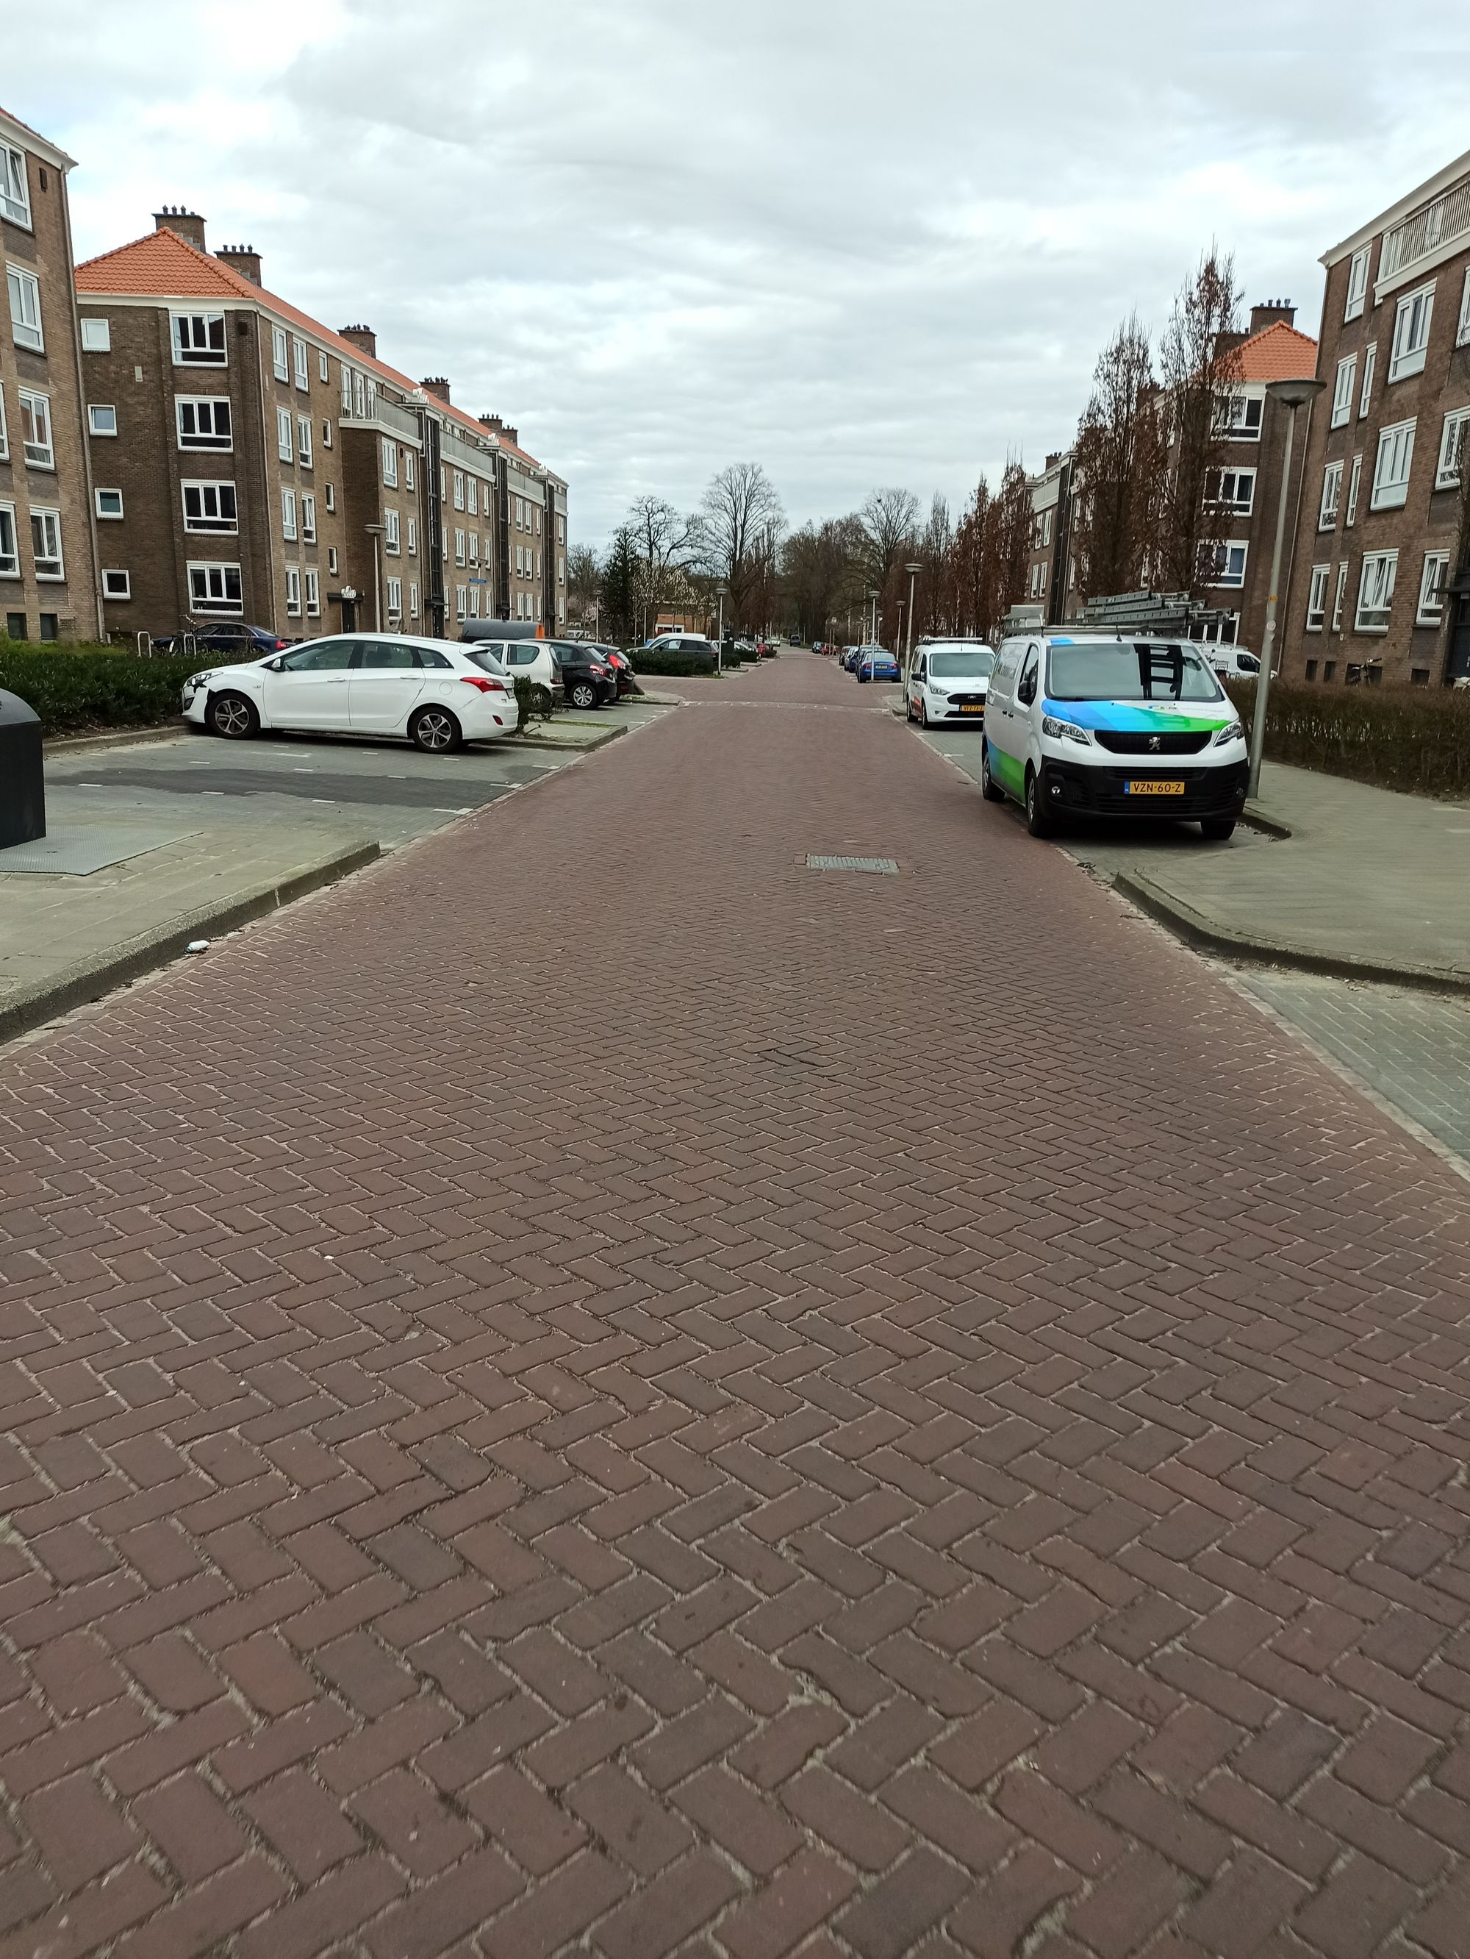

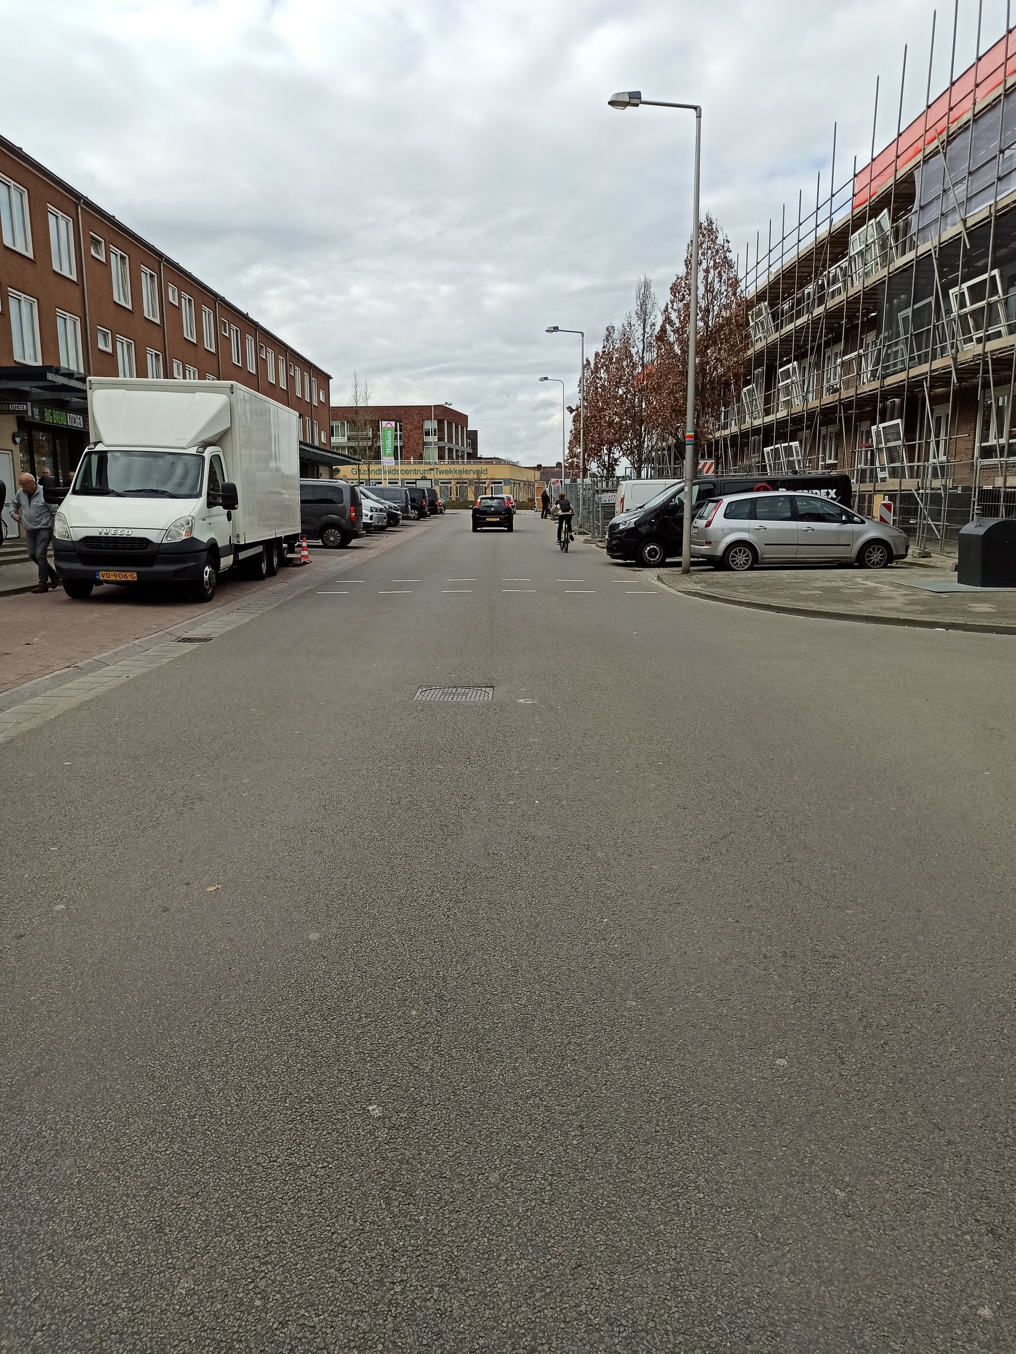

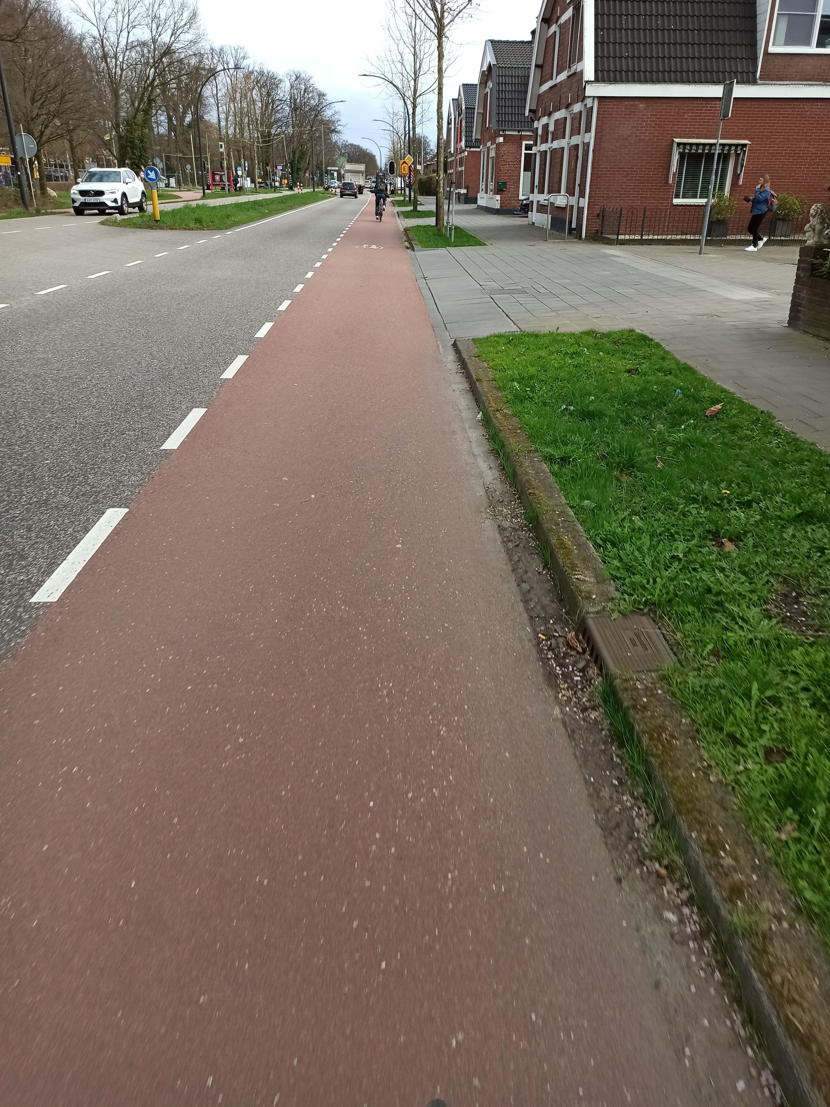

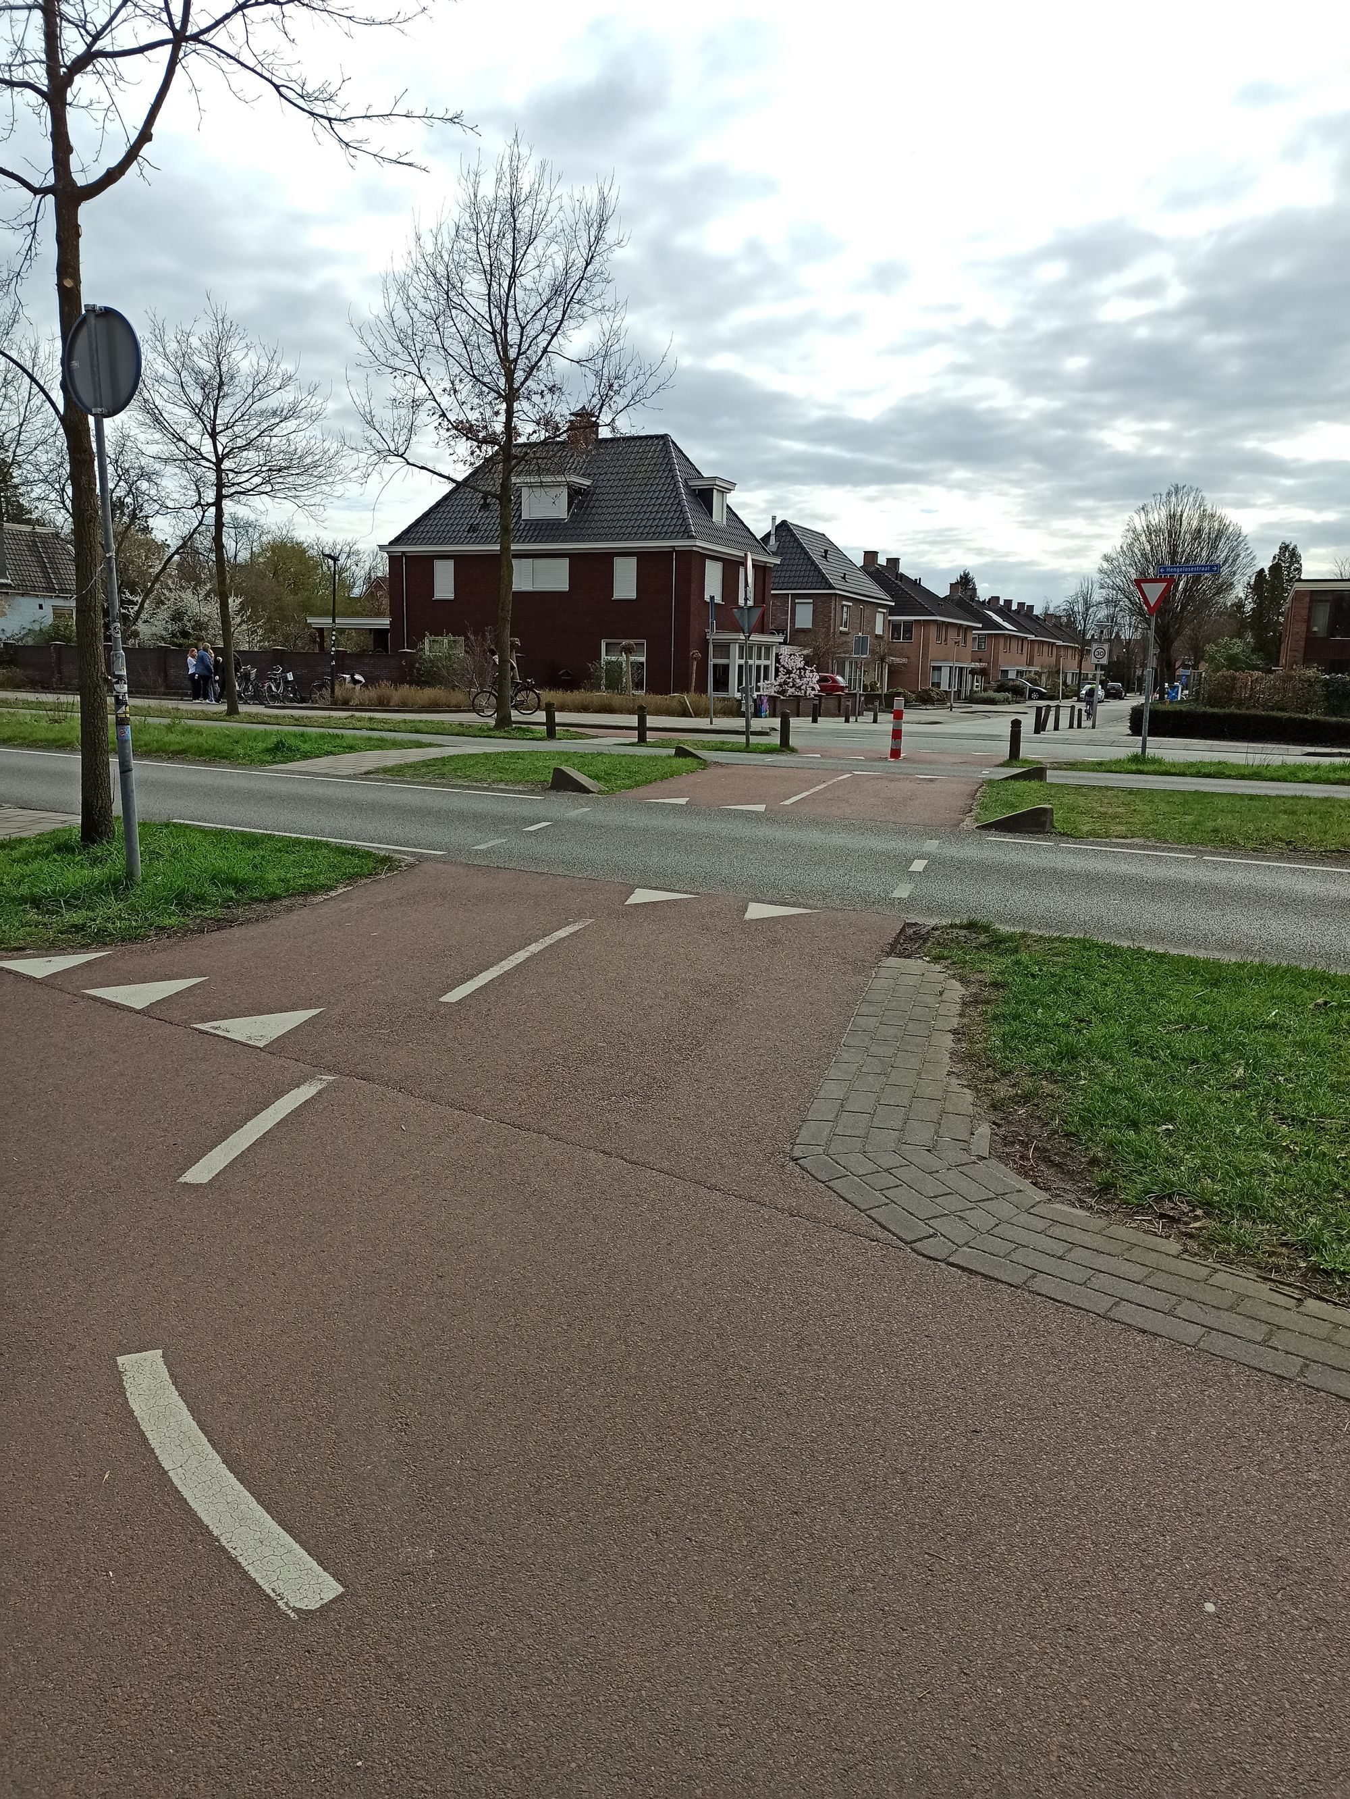

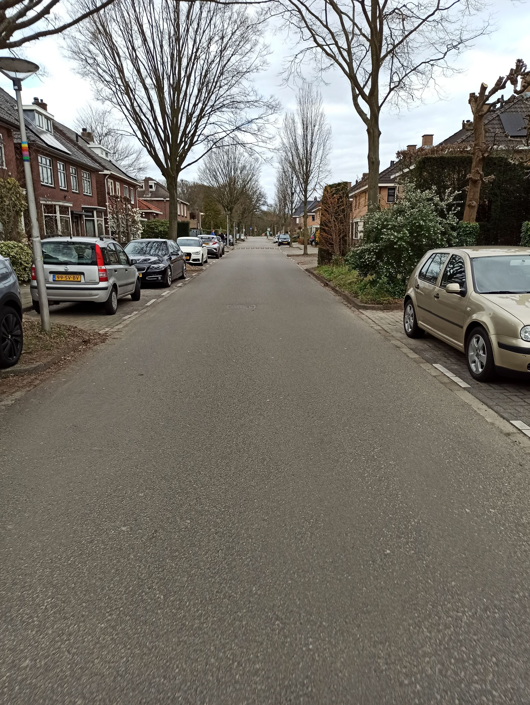

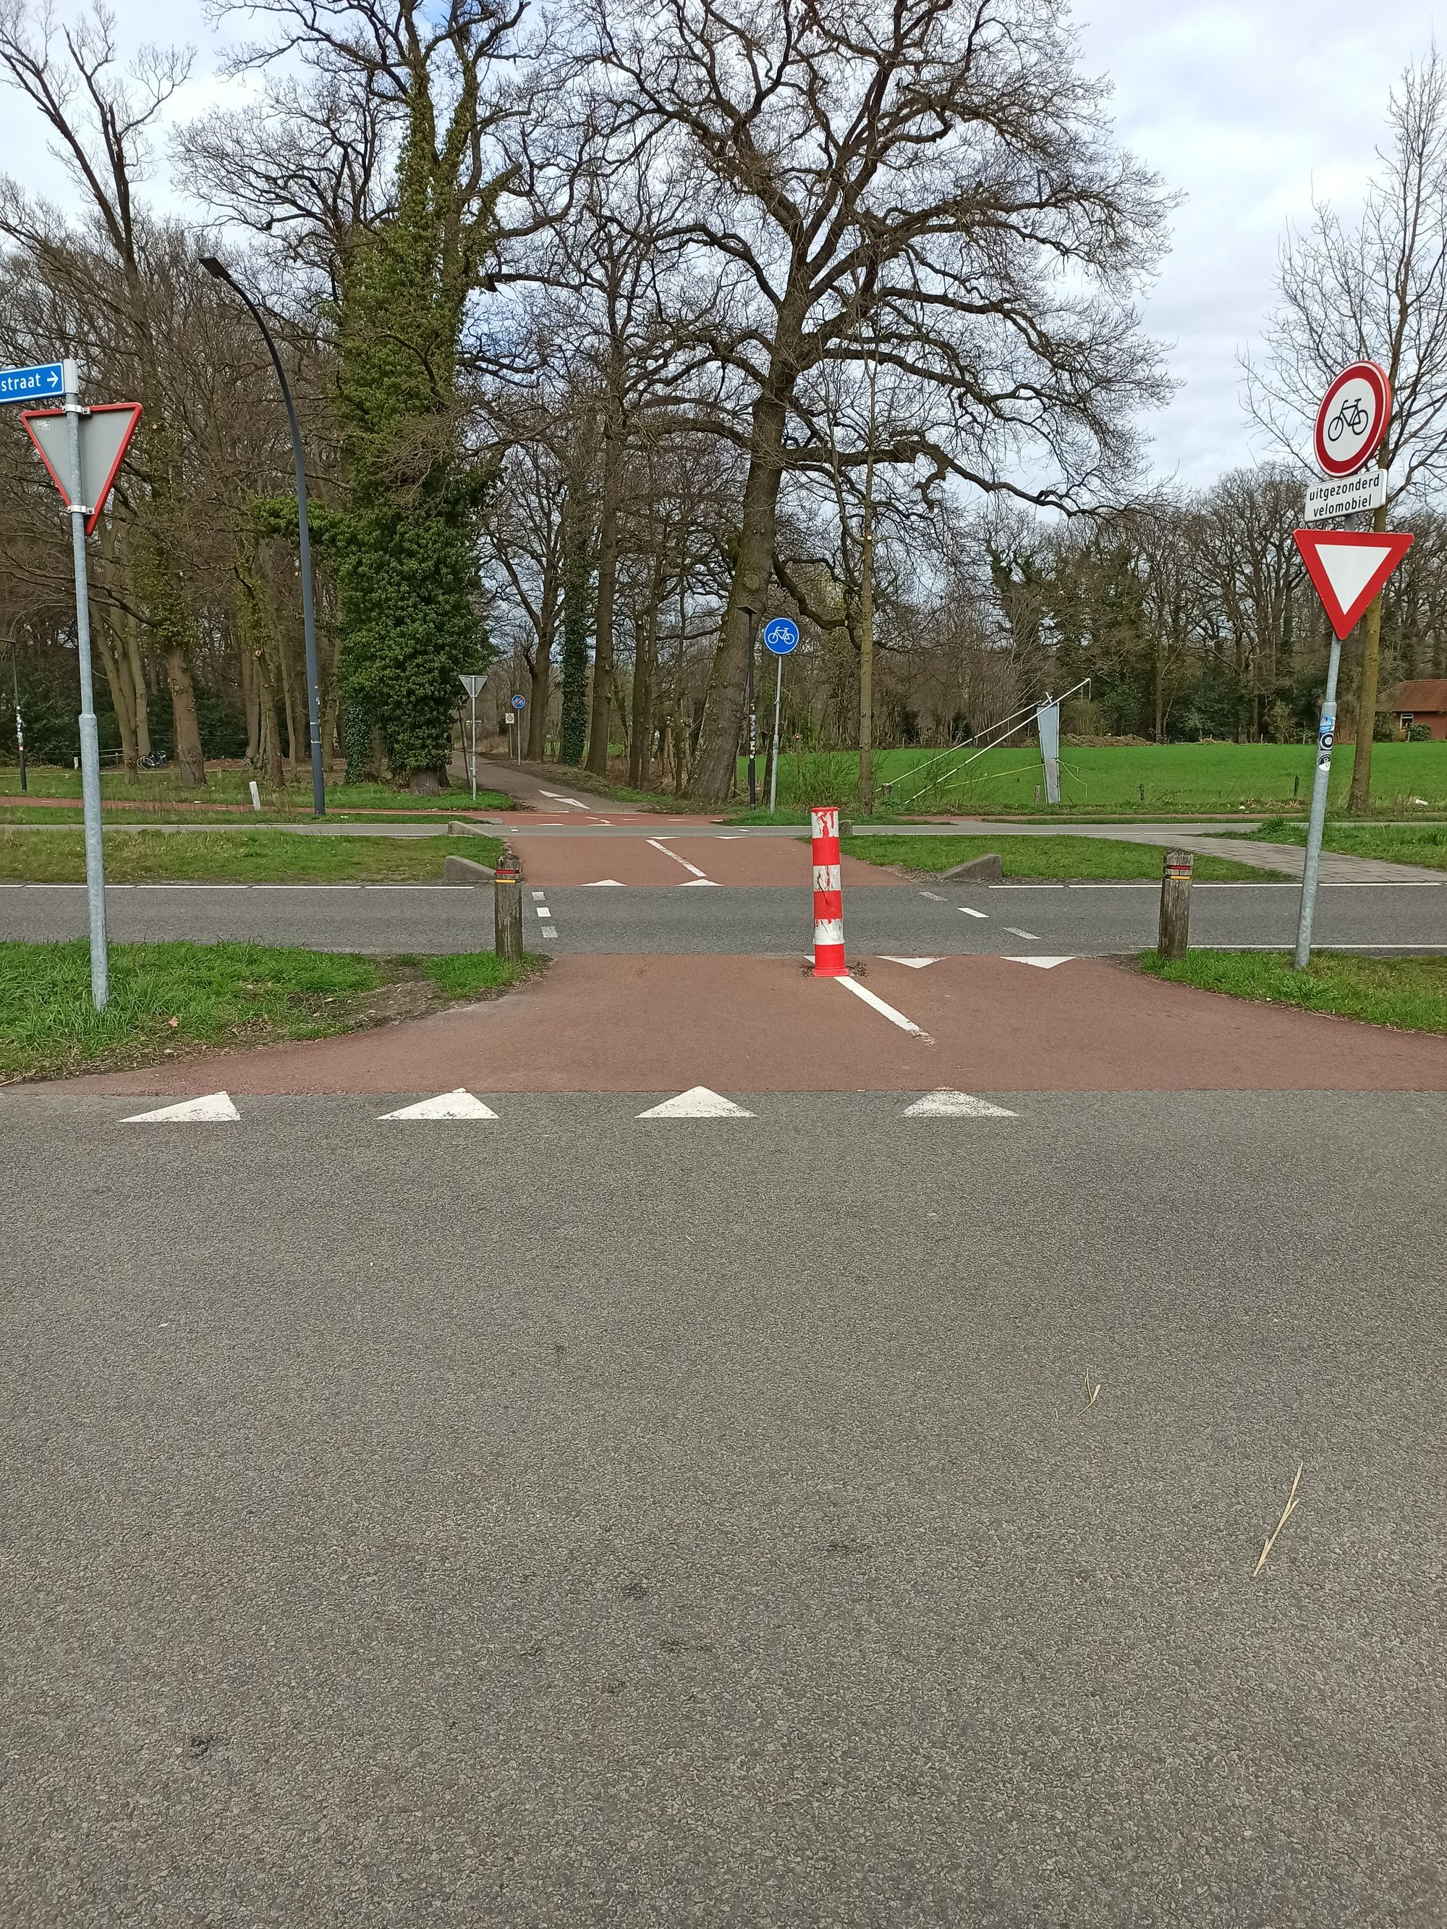

Page 7

# Warning System

In our research, we want to evaluate the design and effects of a warning system. The system warns you to avoid collisions with other road users. The warnings are given at hazardous locations, through visual, audio and/or vibration signals. We would like to ask you some questions about your expectations of this system.

Please indicate to what extent you agree or disagree with the following statements, ranging from strongly disagree to strongly agree.

|  |  |  |  |  |  |
| --- | --- | --- | --- | --- | --- |
|  | Strongly disagree | Disagree | Neutral | Agree | Strongly agree |
| I believe the Warning System will have a positive impact on society. | ◯ | ◯ | ◯ | ◯ | ◯ |
| I would feel safe with a Warning System. | ◯ | ◯ | ◯ | ◯ | ◯ |
| I expect that the Warning System provides me with more safety compared to a normal e-bike. | ◯ | ◯ | ◯ | ◯ | ◯ |
| I would trust the Warning System. | ◯ | ◯ | ◯ | ◯ | ◯ |
| I think with the Warning System I can increase my safety. | ◯ | ◯ | ◯ | ◯ | ◯ |
| I will ride with more stress using a Warning System. | ◯ | ◯ | ◯ | ◯ | ◯ |
| I would like to use the Warning System. | ◯ | ◯ | ◯ | ◯ | ◯ |
| I think that riding with a Warning System can reduce the risk of me getting involved in a crash compared to a conventional bike. | ◯ | ◯ | ◯ | ◯ | ◯ |
| I think that there will be fewer crashes for users with the Warning System. | ◯ | ◯ | ◯ | ◯ | ◯ |
| I think the Warning System would be easy to use. | ◯ | ◯ | ◯ | ◯ | ◯ |
| I expect that the capabilities of the Warning System will meet my requirements. | ◯ | ◯ | ◯ | ◯ | ◯ |

# Go for ride 2!

Page 8

# Questions after ride 2

Now that your ride is completed, we would like to ask you about your current feelings, and about your feelings during the ride.

# Emotions right now

Rate at the slider below this image how energized you feel at the moment.



Voer een waarde in tussen 0 (Low Energy) en 100 (High Energy)

Please enter the time in HH:MM (e.g., 14:21) at which you answered this question.

Rate at the slider below this image how pleasant you feel at the moment.



Voer een waarde in tussen 0 (Unpleasant) en 100 (Pleasant)

Please enter the time in HH:MM (e.g., 14:21) at which you answered this question.

Rate to what extent you were in a flow during the ride.

Voer een waarde in tussen 0 (No flow) en 100 (Full flow)

Rate to what extent you felt safe during the ride.

Voer een waarde in tussen 0 (Unsafe) en 100 (Safe)

# Experiences with the Warning System

Please indicate to what extent you agree or disagree with the following statements, ranging from strongly disagree to strongly agree.

|  |  |  |  |  |  |
| --- | --- | --- | --- | --- | --- |
|  | Strongly disagree | Disagree | Neutral | Agree | Strongly agree |
| I felt safe with the Warning System. | ◯ | ◯ | ◯ | ◯ | ◯ |
| The Warning System provided me with more safety compared to a normal e-bike. | ◯ | ◯ | ◯ | ◯ | ◯ |
| I trusted the Warning System. | ◯ | ◯ | ◯ | ◯ | ◯ |
| I think with the Warning System I can increase my safety. | ◯ | ◯ | ◯ | ◯ | ◯ |
| I rode with more stress using a Warning System. | ◯ | ◯ | ◯ | ◯ | ◯ |
| I would like to use the Warning System. | ◯ | ◯ | ◯ | ◯ | ◯ |
| I think that riding with a Warning System can reduce the risk of me getting involved in a crash compared to a conventional bike. | ◯ | ◯ | ◯ | ◯ | ◯ |
| I think that there will be fewer crashes for users with the Warning System. | ◯ | ◯ | ◯ | ◯ | ◯ |
| The Warning System was easy to use. | ◯ | ◯ | ◯ | ◯ | ◯ |
| The capabilities of the Warning System met my requirements. | ◯ | ◯ | ◯ | ◯ | ◯ |

What aspects (communication, meaning, intensity, etc.) of the warnings did you like?

What aspects (communication, meaning, intensity, etc.) of the warnings bothered you?

Please evaluate the warnings that you received during the ride on the following points:

☐ Very badly noticeable

☐ Badly noticeable

☐ Neutral

☐ Noticeable

☐ Very noticeable

☐ Very demotivating

☐ Demotivating

☐ Neutral

☐ Motivating

☐ Very motivating

☐ Very badly understandable

☐ Badly understandable

☐ Neutral

☐ Well understandable

☐ Very well understandable

☐ Very useless

☐ Useless

☐ Neutral

☐ Useful

☐ Very useful

☐ Strongly worthless

☐ Worthless

☐ Neutral

☐ Assisting

☐ Strongly assisting

☐ Very undesirable

☐ Undesirable

☐ Neutral

☐ Desirable

☐ Very desirable

☐ Strongly reducing alertness

☐ Reducing alertness

☐ Neutral

☐ Raising alertness

☐ Strongly raising alertness

# Influence of context on your experience

Please rate how the following factors influenced your experience with the warnings during the route.

|  |  |  |  |  |  |
| --- | --- | --- | --- | --- | --- |
|  | Strongly negative | Negative | Neutral | Positive | Strongly positive |
| The visual, auditory, and/or vibration warnings | ◯ | ◯ | ◯ | ◯ | ◯ |
| The activity of cycling (intensity, length, fatigue, etc.) | ◯ | ◯ | ◯ | ◯ | ◯ |
| Environment (noise, buildings, landscape, etc.) | ◯ | ◯ | ◯ | ◯ | ◯ |
| Road infrastructure (cycling lanes, intersections, pavement quality, etc.) | ◯ | ◯ | ◯ | ◯ | ◯ |
| Other road users (cars, pedestrians, volume, speeds, proximity, etc.) | ◯ | ◯ | ◯ | ◯ | ◯ |
| Weather (wind, temperature, sunshine, etc.) | ◯ | ◯ | ◯ | ◯ | ◯ |
| Mood (average weekly feelings, memories, etc.) | ◯ | ◯ | ◯ | ◯ | ◯ |
| Fitness (personal strength, health condition, etc.) | ◯ | ◯ | ◯ | ◯ | ◯ |

# Go for ride 3!

Page 9

# Questions after ride 3

Now that your ride is completed, we would like to ask you about your current feelings, and about your feelings during the ride.

# Emotions right now

Rate at the slider below this image how energized you feel at the moment.



Voer een waarde in tussen 0 (Low Energy) en 100 (High Energy)

Please enter the time in HH:MM (e.g., 14:21) at which you answered this question.

Rate at the slider below this image how pleasant you feel at the moment.



Voer een waarde in tussen 0 (Unpleasant) en 100 (Pleasant)

Please enter the time in HH:MM (e.g., 14:21) at which you answered this question.

Rate to what extent you were in a flow during the ride.

Voer een waarde in tussen 0 (No flow) en 100 (Full flow)

Rate to what extent you felt safe during the ride.

Voer eenwaarde in tussen 0 (Unsafe) en 100 (Safe)

# Experiences with the Warning System

Please indicate to what extent you agree or disagree with the following statements, ranging from strongly disagree to strongly agree.

|  |  |  |  |  |  |
| --- | --- | --- | --- | --- | --- |
|  | Strongly disagree | Disagree | Neutral | Agree | Strongly agree |
| I felt safe with the Warning System. | ◯ | ◯ | ◯ | ◯ | ◯ |
| The Warning System provided me with more safety compared to a normal e-bike. | ◯ | ◯ | ◯ | ◯ | ◯ |
| I trusted the Warning System. | ◯ | ◯ | ◯ | ◯ | ◯ |
| I think with the Warning System I can increase my safety. | ◯ | ◯ | ◯ | ◯ | ◯ |
| I rode with more stress using a Warning System. | ◯ | ◯ | ◯ | ◯ | ◯ |
| I would like to use the Warning System. | ◯ | ◯ | ◯ | ◯ | ◯ |
| I think that riding with a Warning System can reduce the risk of me getting involved in a crash compared to a conventional bike. | ◯ | ◯ | ◯ | ◯ | ◯ |
| I think that there will be fewer crashes for users with the Warning System. | ◯ | ◯ | ◯ | ◯ | ◯ |
| The Warning System was easy to use. | ◯ | ◯ | ◯ | ◯ | ◯ |
| The capabilities of the Warning System met my requirements. | ◯ | ◯ | ◯ | ◯ | ◯ |

What aspects (communication, meaning, intensity, etc.) of the warnings did you like?

What aspects (communication, meaning, intensity, etc.) of the warnings bothered you?

Please evaluate the warnings that you received during the ride on the following points:

☐ Very badly noticeable

☐ Badly noticeable

☐ Neutral

☐ Noticeable

☐ Very noticeable

☐ Very demotivating

☐ Demotivating

☐ Neutral

☐ Motivating

☐ Very motivating

☐ Very badly understandable

☐ Badly understandable

☐ Neutral

☐ Well understandable

☐ Very well understandable

☐ Very useless

☐ Useless

☐ Neutral

☐ Useful

☐ Very useful

☐ Strongly worthless

☐ Worthless

☐ Neutral

☐ Assisting

☐ Strongly assisting

☐ Very undesirable

☐ Undesirable

☐ Neutral

☐ Desirable

☐ Very desirable

☐ Strongly reducing alertness

☐ Reducing alertness

☐ Neutral

☐ Raising alertness

☐ Strongly raising altertness

# Influence of context on your experience

Please rate how the following factors influenced your experience with the warnings during the route.

|  |  |  |  |  |  |
| --- | --- | --- | --- | --- | --- |
|  | Strongly negative | Negative | Neutral | Positive | Strongly positive |
| The visual, auditory, and/or vibration warnings | ◯ | ◯ | ◯ | ◯ | ◯ |
| The activity of cycling (intensity, length, fatigue, etc.) | ◯ | ◯ | ◯ | ◯ | ◯ |
| Environment (noise, buildings, landscape, etc.) | ◯ | ◯ | ◯ | ◯ | ◯ |
| Road infrastructure (cycling lanes, intersections, pavement quality, etc.) | ◯ | ◯ | ◯ | ◯ | ◯ |
| Other road users (cars, pedestrians, volume, speeds, proximity, etc.) | ◯ | ◯ | ◯ | ◯ | ◯ |
| Weather (wind, temperature, sunshine, etc.) | ◯ | ◯ | ◯ | ◯ | ◯ |
| Mood (average weekly feelings, memories, etc.) | ◯ | ◯ | ◯ | ◯ | ◯ |
| Fitness (personal strength, health condition, etc.) | ◯ | ◯ | ◯ | ◯ | ◯ |

Mage 10

# Many thanks!

Do you have any further comments or questions?

Can we contact you for future participation?

☐ Yes

☐ No

☐ Maybe

Would you like to stay up to date about our research?

☐ Yes

☐ No

Email address (for future participation and/or research updates)

Congratulations, you finished the survey! We are very thankful for your participation. The results will be meaningful for the Smart Connected Bike project and beyond. You can contact us any time in case of questions or ideas. Best regards, The Research Team

Click the button below to submit your answers. Many thanks again for your participation!